
Saad Mughal
F2023-009
Total Marks: 10
Due 30 March 2026

Computer Networks LAB

Week 6

TCP Client Server Communication

Course Lecturer: Shaiza Rizwan
Lab Instructor: Hasnain Ahmad
Section: C

Computer Networks LAB (LAB-209) - Lab 04
Socket Programming: TCP Client Server Communication

Task 1
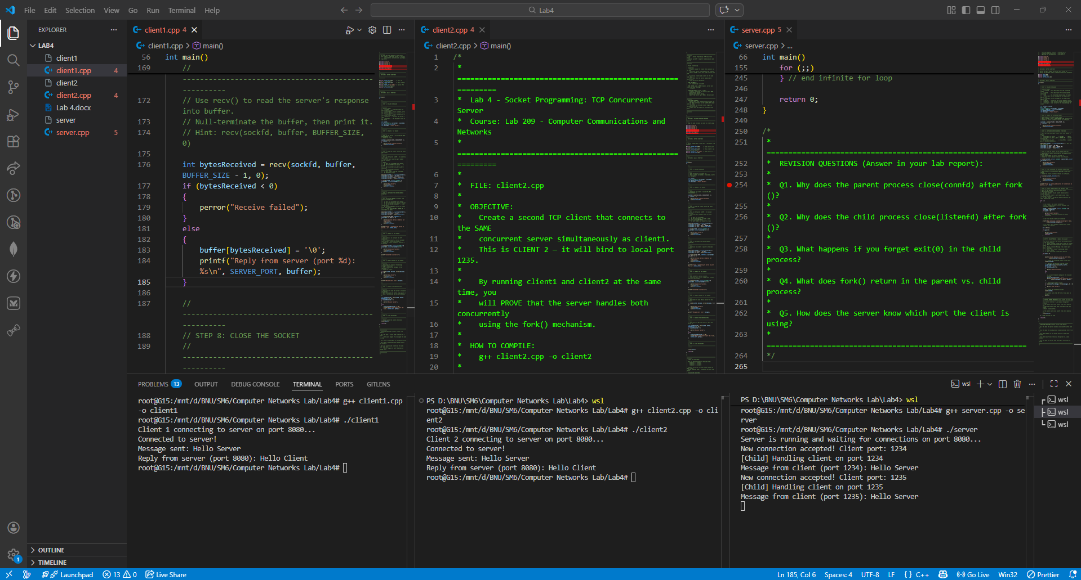

Revision Questions

server.cpp
Q1. Why does the parent process close(connfd) after fork()?
The parent process closes connfd because it hands over the responsibility of handling that specific client connection to the child process. Keeping it open in the parent would consume unnecessary file descriptors and potentially cause resource leaks, as the parent only needs to return to accepting new connections.
Q2. Why does the child process close(listenfd) after fork()?
The child process is an exact copy of the parent process, meaning all descriptors opened in the parent are shared by the child. However, the child's sole job is to process the request using the connfd. It does not need to listen for new incoming connections, so it closes the listening socket.
Q3. What happens if you forget exit(0) in the child process?
If the child process does not call exit(0) after serving the client, it will fall out of the if (pid == 0) block and loop back to the top of the infinite for(;;) loop. The child process would then try to act like the server parent, attempting to accept() new connections, leading to chaotic behavior and multiple processes trying to handle the same port.
Q4. What does fork() return in the parent vs. child process?
The fork() function is called once but returns twice. It returns an integer value representing the parent process ID (ppid) to the parent process, and it returns a value of 0 to the newly created child process.
Q5. How does the server know which port the client is using?
When the server successfully calls the accept() function, it populates the clientAddr struct (which was passed by reference) with the connection details of the client. The server can then read clientAddr.sin_port to find the port number.

client1.cpp
Q1. Why does a client need to bind() to a port? What would happen if we skipped the bind() step?
In this specific lab scenario, we explicitly bind the client to port 1234 to give it a guaranteed, recognizable identity for demonstration purposes. If we skipped the bind() step, the operating system would automatically assign a random, available "ephemeral port" to the client upon calling connect().
Q2. What is the purpose of inet_pton() here?
inet_pton() stands for "Internet Presentation to Numeric." It takes the human-readable string representation of an IP address (like "127.0.0.1") and converts it into the binary format needed by the sockaddr_in structure.
Q3. What is the difference between send() and write()?
write() is a general-purpose system call used for writing data to any file descriptor (files, pipes, terminals). send() is specifically designed for socket file descriptors and allows you to pass an additional flags argument to change the behavior of the network transmission.
Q4. Run client1 and client2 at the same time. Does the server respond to both? How does it manage that?
Yes, the server responds to both clients simultaneously. It manages this because it is a TCP concurrent server that utilizes the fork() system call to create a duplicate child process for every newly accepted connection. The child handles the client communication while the parent process immediately goes back to waiting for more connections.

client2.cpp
Q1. How many child processes does the server create in this run? What are their PIDs?
The server creates exactly two child processes, one for Client 1 and one for Client 2. The exact PIDs will vary every time you run the code depending on the OS's process scheduler (e.g., they might be 3451 and 3452). (Note: I added a getpid() call in the child process code block of server.cpp so you can observe the exact PIDs in your terminal!).
Q2. What would happen if the server used an iterative design instead of fork()? Would client2 connect while client1 is still being served?
If the server used an iterative design, only one client could talk to the server at a time. Client 2 would not be served until Client 1 entirely closed its connection. Client 2's connection request would sit in the listening queue (BACKLOG) waiting for the server to finish with Client 1.
Q3. Modify the server to print its PID and the child's PID every time fork() is called.
The getpid() function is called within the child block to print its own PID, and the parent can print the pid variable returned from fork() to see the child's PID).

